

**Immersion Day**

***Introduction to Monitoring on AWS***

# Overview

Amazon CloudWatch monitors your Amazon Web Services (AWS) resources and the applications you run on AWS in real-time. You can use CloudWatch to collect and track metrics, which are the variables you want to measure for your resources and applications. CloudWatch alarms send notifications or automatically make changes to the resources you are monitoring based on rules that you define. For example, you can monitor the CPU usage and disk reads and writes of your Amazon Elastic Compute Cloud (Amazon EC2) instances and then use this data to determine whether you should launch additional instances to handle increased load. You can also use this data to stop under-used instances to save money. In addition to monitoring the built-in metrics that come with AWS, you can monitor your own custom metrics. With CloudWatch, you gain system-wide visibility into resource utilization, application performance, and operational health.

In this lab, you will utilize CloudWatch to track EC2 CPU utilization and set up Alarm based on a configured threshold. The Alarm will trigger a Simple Notification Service (SNS) notification. As an optional exercise, you will utilize CloudWatch to monitor Billing and send a notification if estimated charges are above a defined threshold.

# Part 1: Create Simple Notification Service (SNS) Topic

First, we will set up a topic for notifying our email address that we will then be attaching to our alarm.

1. From the AWS console click Services > SNS.
2. On the left side of the screen, select Topics.
3. Click “Create topic”
4. In the Name field , type a name for your topic that includes your name and optionally a Display Name. Scroll to the bottom of the screen and click “Create topic”  
     
   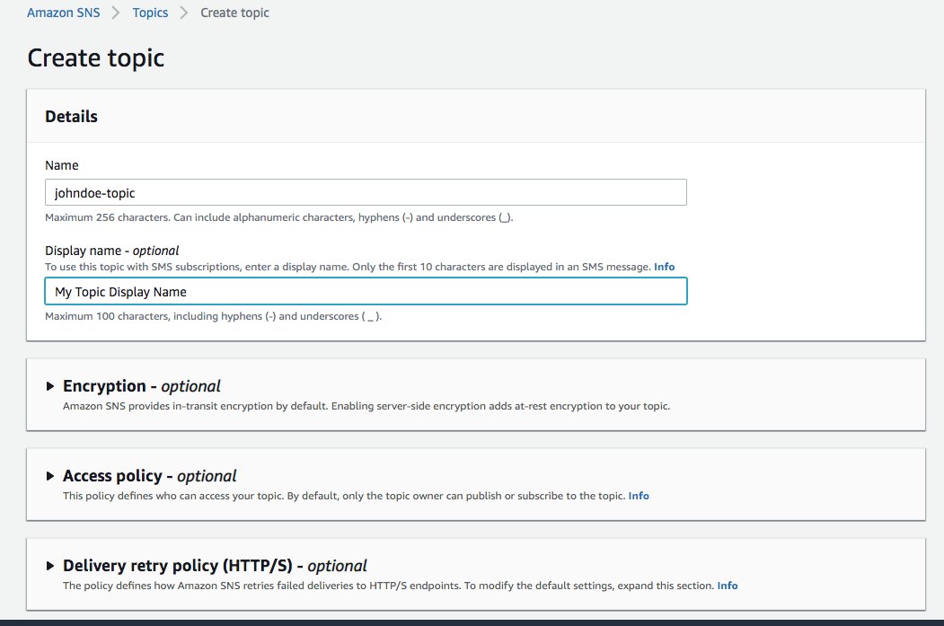
5. Creating the topic will bring you to the topic’s specific dashboard. Click “Create subscription” on the right side of the screen.  
     
   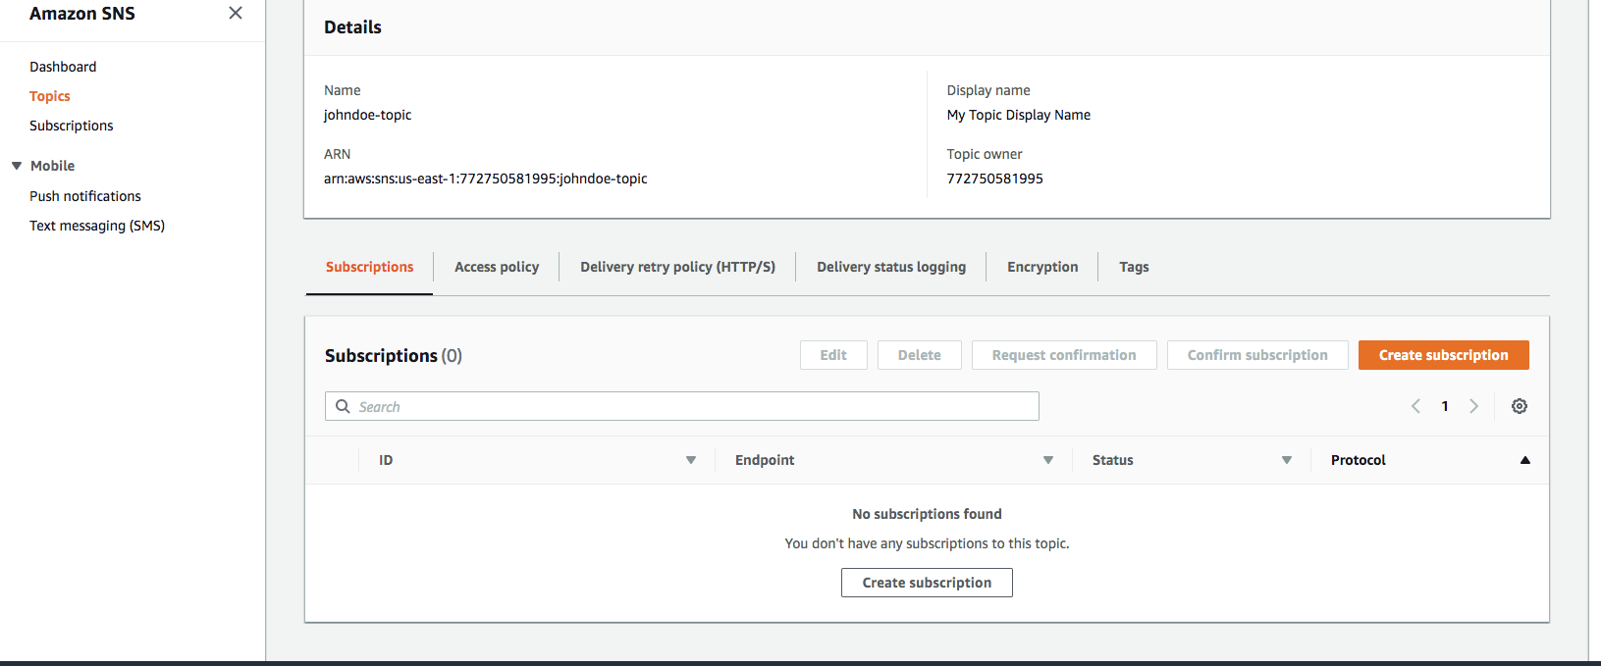
6. In the Protocol drop down select Email and enter a working email address you are able to access. Utilize a non-business email if there may potentially be a spam filter that will block the SNS messages. Click Create Subscription.  
     
   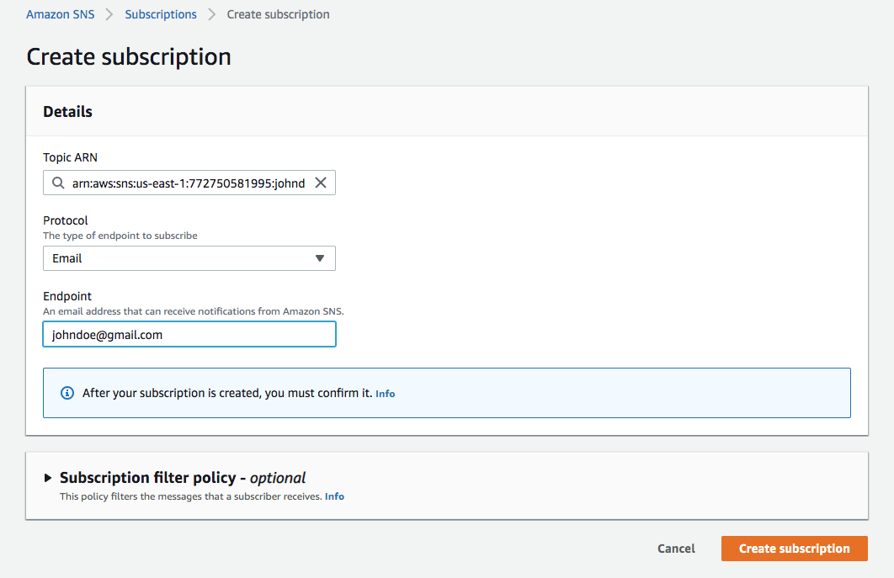
7. A verification email will be sent to your address with the subject “AWS Notification – Subscription Confirmation”. Open the email and click the Confirm Subscription link.
8. Your subscription should now be active and not “PendingConfirmation” under the Subscriptions section in the SNS console.

# Part 2: Launch an Elastic Compute Cloud (EC2) Instance

In this step you will launch an EC2 instance and configure the User Data to install and launch the stress tool. The stress tool will begin simulating CPU load 5 minutes after the instance launches to allow you time to configure the CloudWatch Alarm.

*If you don’t have VPC created yet, create a VPC as below. You can skip this step if you already created a VPC.*

*Create a VPC*

1. *In AWS management console*

* *Choose VPC from the services (you may need to type VPC in the search bar).*

1. *In VPC dashboard*

* *Choose Launch VPC Wizard and click Select.*

1. *Type VPC name (EMRVPC for example), and leave all the rest as default.*
2. *Click Create and then OK.*
3. Click EC2 Dashboard towards the top of the left menu.
4. Click on Launch Instance  
   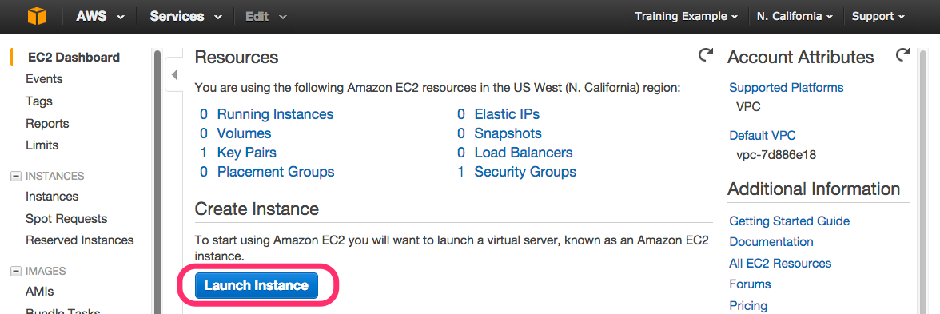
5. In the Quick Start section, select the “Amazon Linux AMI” and click Select  
   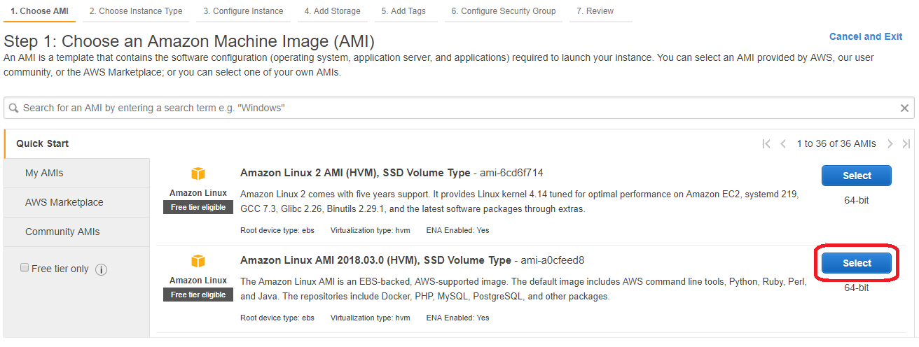  
   PLEASE NOTE: You must select “Amazon Linux AMI”, NOT “Amazon Linux 2 AMI”! This lab will not work properly if you select Amazon Linux 2.
6. Select the General purpose t2.micro instance type and click Next: Configure Instance Details  
   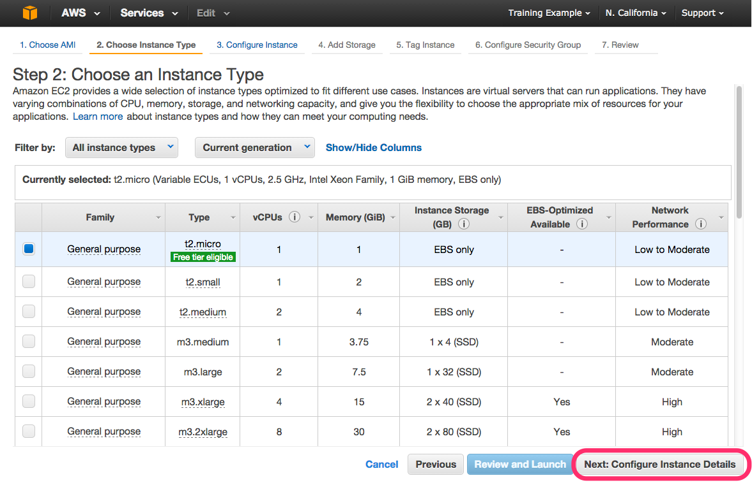
7. Now we will add a script that will create a test stress script to simulate hits on your instance. Still on the Configure Instance Details page, expand the Advanced Details section at the bottom of the page, and type the following initialization script information into the User Data field (this will automatically install and start the stress tool):

#!/bin/bash  
yum -y update   
yum -y install stress  
stress -c 1 --backoff 300000000 -t 30m

1. Click Next: Add Storage



1. Click Next: Add Tags to accept the default Storage Device Configuration.
2. Click Add Tag. Write “Name” in the Key placeholder. Then choose a reasonable name value for your instance. This name, more correctly known as a tag, will appear in the console once the instance launches. It makes it easy to keep track of running machines in a complex environment.
   1. For this lab, you can name yours in this format: “[Your Name] Server”. Then click Next: Configure Security Group

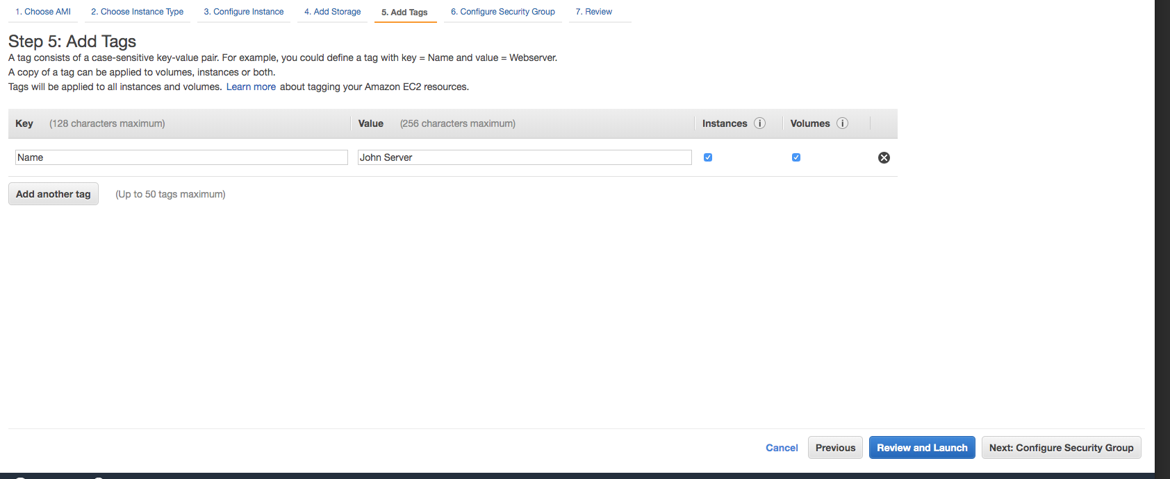

1. Remove the Security Group rule with by clicking the “x” on the right so there are no rules. (You will not need to connect with this instance). Then click Review and Launch.  
     
   
2. Review your Instance Launch Configuration, and then click Launch.

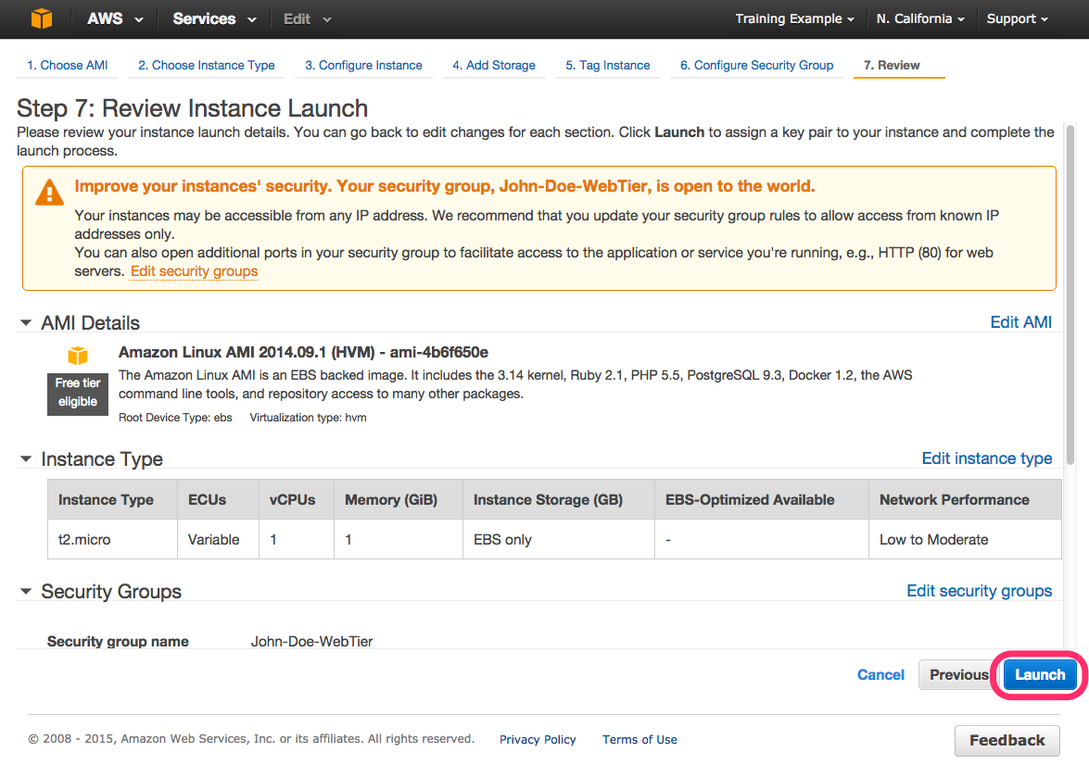

1. In the drop down choose “Proceed without a keypair” and click Launch Instances.



1. Click View Instances button in the lower right-hand portion of the screen to view the list of EC2 instances. Once your instance has launched, you will see your server as well as the Availability Zone the instance is in.

# Part 3: Configure a CloudWatch Alarm

1. In the EC2 Console, click the checkbox next to your server name to view details about this EC2 instance. Click the Monitoring tab and then click Enable Detailed Monitoring to provide monitoring data at a 1 minute interval vs. the default of 5 minutes.  
     
   
2. Click the Description tab and copy your “Instance ID” to the clipboard or other location such as a notepad.
3. Click the Monitoring tab and click Create Alarm.  
     
   
4. To the right of the “Send a notification to:” drop down, select the SNS Topic you created in the previous step.
   1. In the “Whenever:” field, set the Average of CPU Utilization to “>=” 60%. In the “For at least:” field, set the “Consecutive periods to 1 Minute.
   2. Add your name to the “Name of alarm:” field and click Create Alarm. **Note:** If 1 minute period is not an option, refresh the page. This is because 1 minute is only available under the Detailed Monitoring that you just enabled, and sometimes needs a refresh to become visible.



1. In the top left area of the AWS Console select Services > CloudWatch.
2. Click Alarms in the left pane of the Console and check the State of your alarm. It most likely says INSUFFICIENT_DATA because you just created it.



1. In the CloudWatch Console select Metrics in the left pane. Select the All Metrics tab and paste your Instance ID into the filter. Add an additional filter “cpu”. Select CPUUtilization metric. Select the Graphed metrics tab and change the Period to 1 Minute. Change the graph interval to a custom value of 30m and select Auto refresh of 1min.  
     
   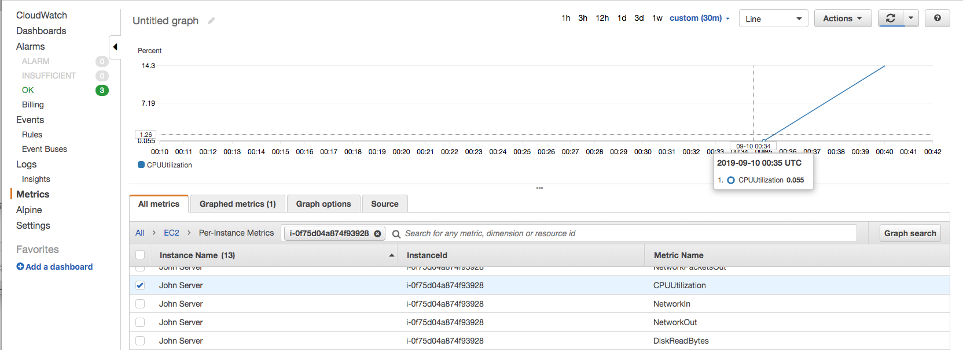
2. After 5 minutes, the stress tool will begin to simulate CPU workload and trigger the Alarm once the threshold is reached. You can view the Alarm state in the CloudWatch console under Alarms. If you setup an email notification you will receive an email alert when the Alarm is triggered.  
     
   

You have successfully configured a CloudWatch Alarm!

***Clean Up:*** Be sure to delete the following resources after you are finished:

* + - Select Delete on your alarm after you are finished.
    - Stop and terminate your EC2 instance.
    - Delete your SNS topic.